Natural Language Processing

For the given grammar apply bottom up strategy for the string:
Allen ate the chocolate
- S: NP VP
- NP: ART N
- NP: NAME
- VP: V NP
- NAME: Allen
- N: Chocolate
- V: ate
- ART: an/the

S: Allen ate the chocolate
S: Allen ate the N
S: Allen ate ART N
S: Allen V ART N
S: NAME V ART N
S: NAME V NP
S: NAME VP
S: NP VP

Top-Down Parsing Algorithm:
Algorithm starts with initial state ((S),1) with no backup states
Step 1: Select the current state
Take the first state of the possibilities list and call it as C
If the possibilities list is empty then the algorithm fails. i.e Not possible to parse a string
Step 2: If C consists of an empty symbol list and the word position is at the end of the sentence then, the algorithm succeeds.
Step 3: Otherwise generate the next possible states.
3.1: If the first symbol on the symbol list of C is a lexical symbol and the next word in the sentence can be in that class then create a new state by removing the first symbol from the symbol list and updating the word position and add it to the possibilities list.
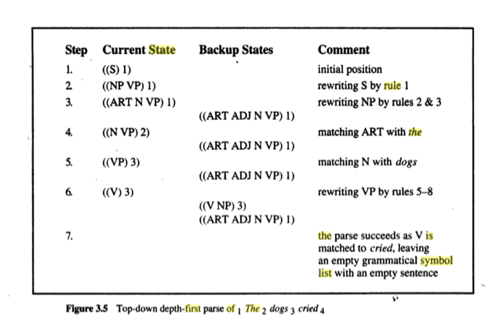
3.2: If the first symbol on the symbol list of C is a non terminal, then generate a new state for each rule in the grammar that can rewrite that non terminal symbol and add them to the possibilities list.

